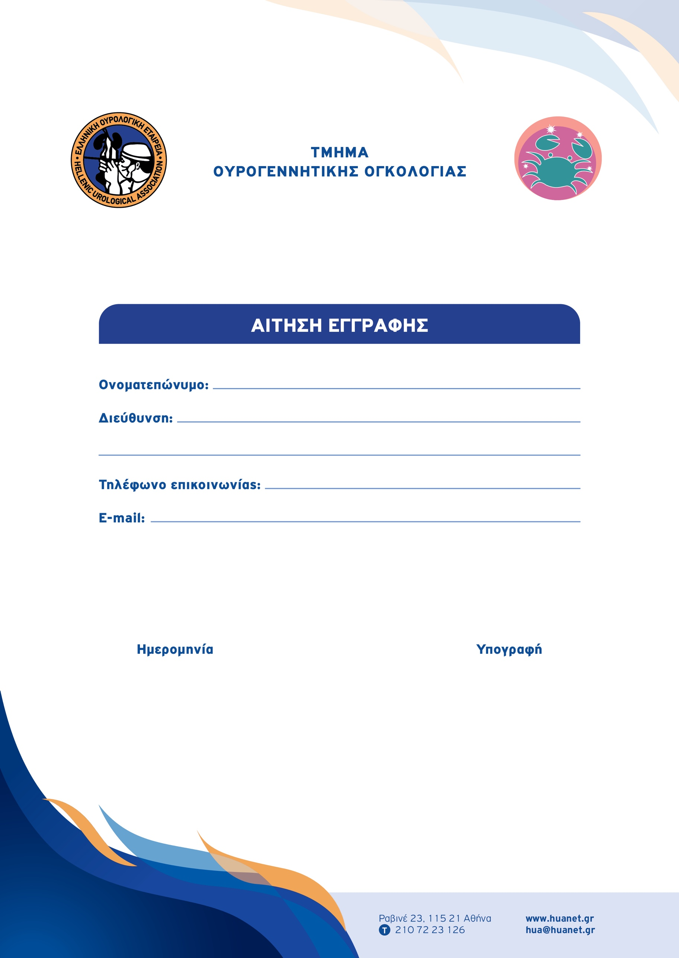

Type to enter text

Type to enter text

Type to enter text

Type to enter text

Type to enter text